RadPiper

RadPiper is the latest iteration of PCAMS (Pipe Crawling Activity Measurement System). This is a robotic system commissioned by the United States Department of Energy to assist in the cleanup of retired nuclear plants. The robot automates the task of measuring where dangerous levels of radioactive material has built up on the inside of miles of piping.

Radpiper is developed by a group of Carnegie Mellon students under the direction of Red Whittaker I have worked off and on for the project as the only User Experience Designer on the team. During that time, I prototyped interfaces for previous iterations of the robot (Pipe Dream) and designed a tracking and labeling system for the robot and its wide range of support equipment.

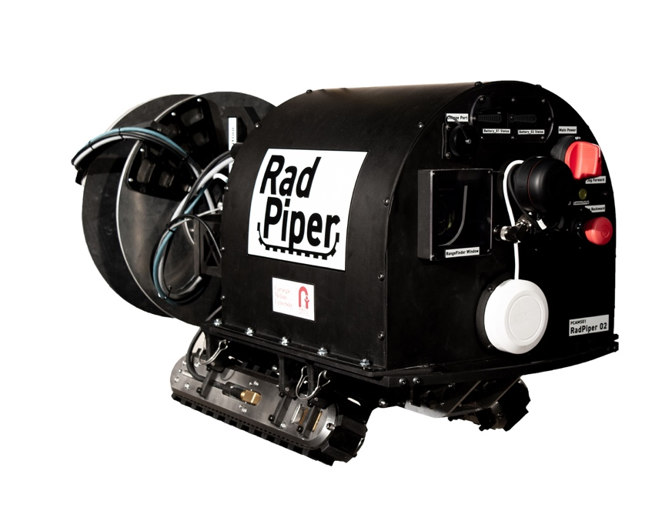

DESIGNING A TRACKING & LABELING SYSTEM

The first step in designing the tracking system for RadPiper was to actually determine what it is we were tracking. By the end of the project our scheme was tracking approximately 300 individual parts of the robot or support equipment.

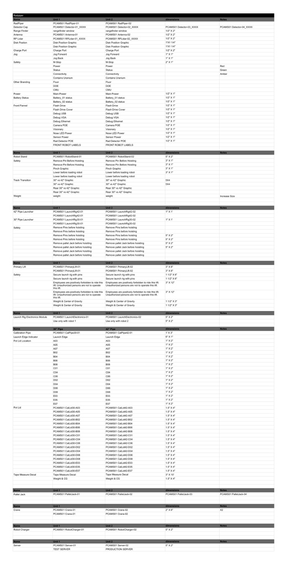

In order to make sense of a labeling scheme that large we needed to develop a system which allowed users to easily identify what the component they were looking at was and which version of the item it was. This is a breakdown of a fairly average label for one of the 42” RadPiper Launch Rigs.

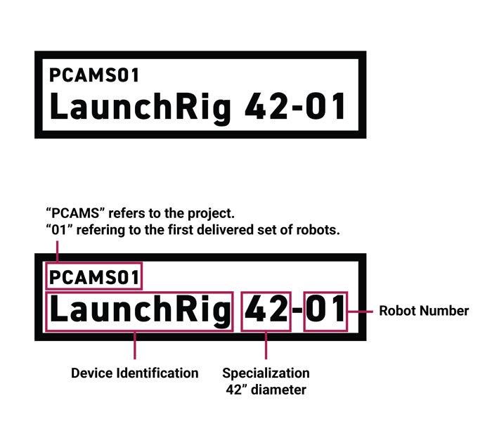

In addition to tracking labels we also implemented a variety of custom safety warnings and usage guidelines.

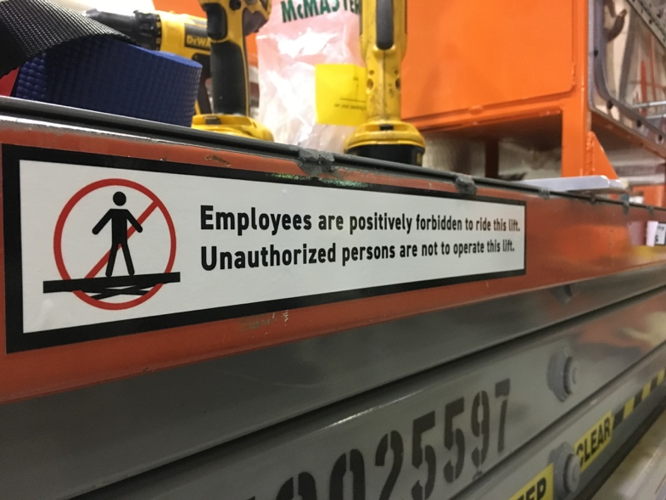

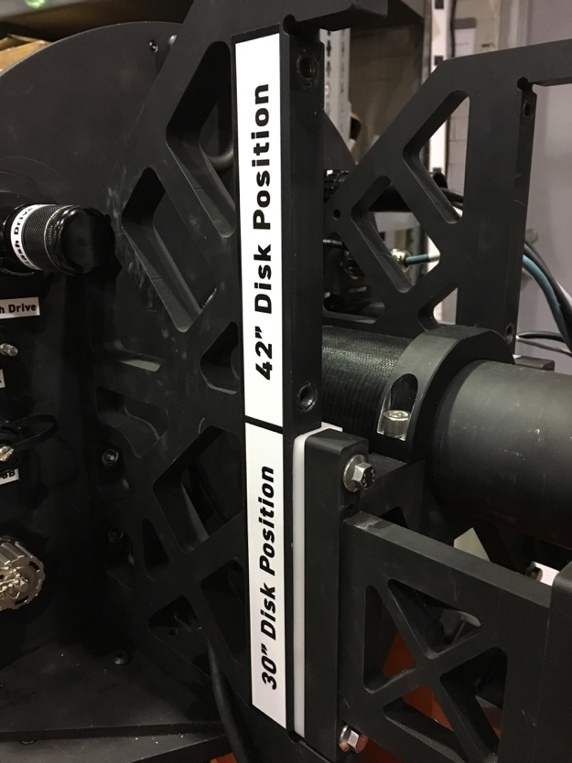

PIPE DREAM PREVIEW USER INTERFACE

Pipe Dream is a previous iteration of the RadPiper project. It is distinguished primarily by its methods its method for determining harmful levels of radiation. While RadPiper uses a Radiation Detector to indirectly measure the levels of buildup on the pipe walls Pipe Dream sought to measure those deposits directly.

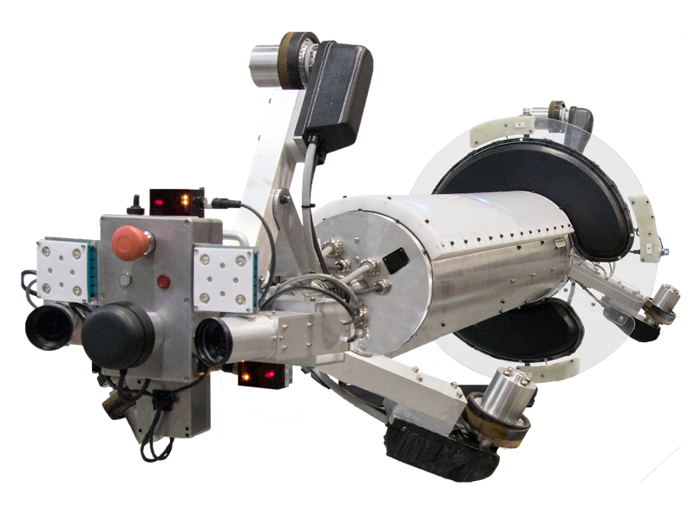

As a result of this different method we decided a manual, visual review of the pipe would be able to boost our levels of confidence in the model significantly. In particular the deposit’s properties under UV light made this inspection particularly useful. Our first challenge was how to use the two cameras on the front of the rover to generate a easy to understand visualization of the interior of the tube.

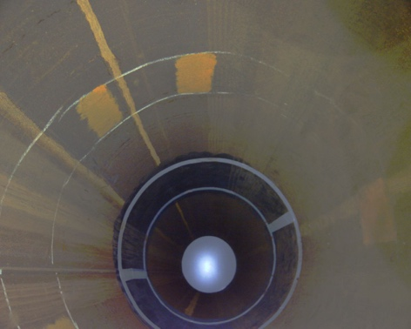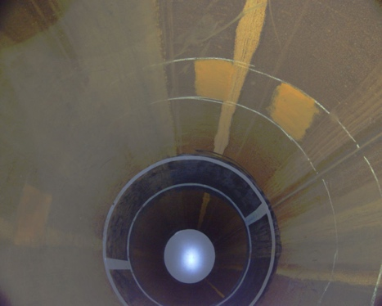

Even when combining the images together to generate a single image we realized it was still difficult for a user to accurately predict how the data collected by the robot lined up with what they were seeing.

What we realized was that we needed to create a linear image which could be compared directly to the robot’s data. By taking a small strip from each image the robot took and stitching each photo to the next we were able to create an unwrapped version of the interior of the pipe. By doing this with both regular and UV light we were able to quickly identify deposits inside the pipe.

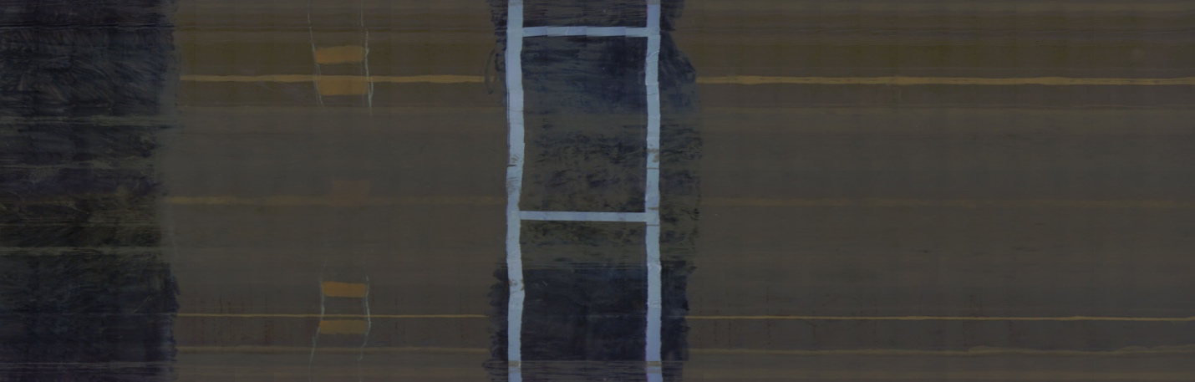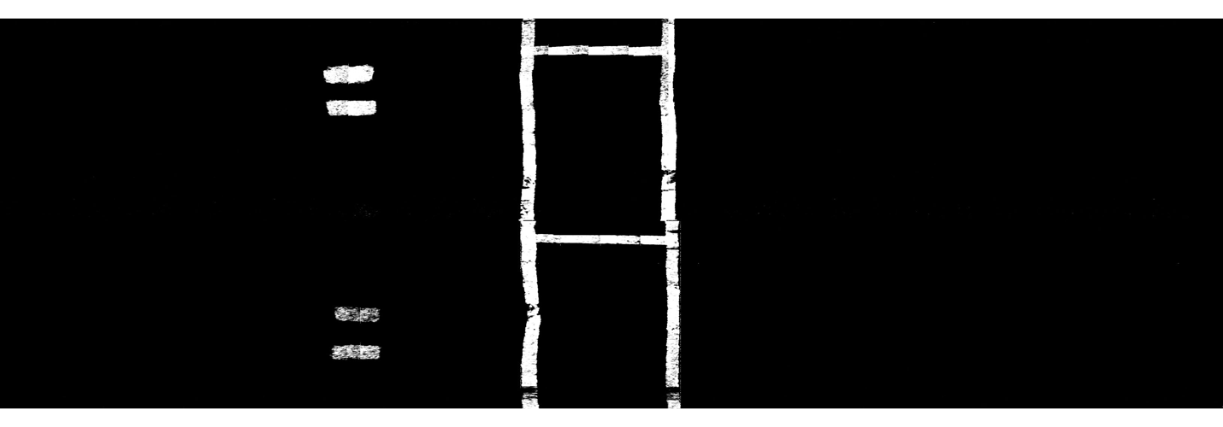

Finally, we designed an interface which would let an onsite operator quickly compare the visuals inside the pipe to the data collected directly by the robot and make decisions about which parts of the pipes could be safely removed from the site.

